1. a) Initial phase: characterize fully the data needs of the prospective database users

Second phase - choosing data model:

1.Applying the concepts of the chosen data model.

2.Translating these requirements into a conceptual schema of the database.

3.A fully developed conceptual schema indicates the functional requirements of the enterprise.

Final Phase: Moving from an abstract data model to the implementation of the database

b) Entity: a “thing” or “object” in the enterprise that is distinguishable from other objects (person, company event).

Entity is a set of atrributes: instructor = (ID, name, salary ).

Relationship: an association among several entities.

1. a)

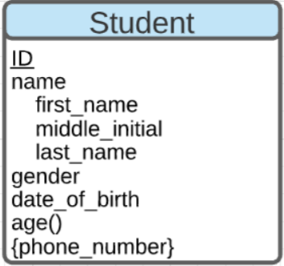

b)

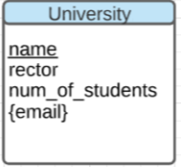

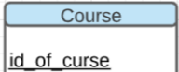

Name

Credits

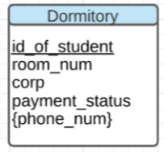

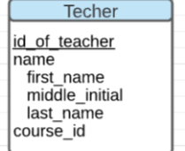

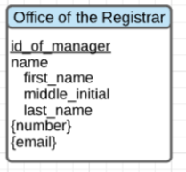

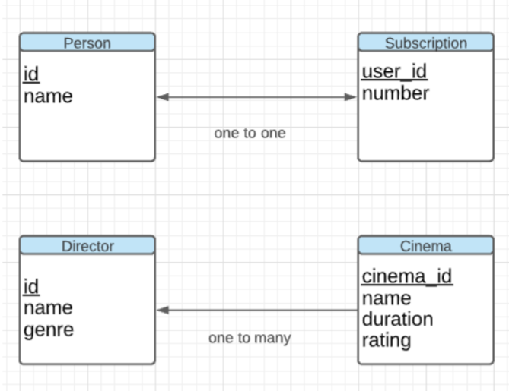

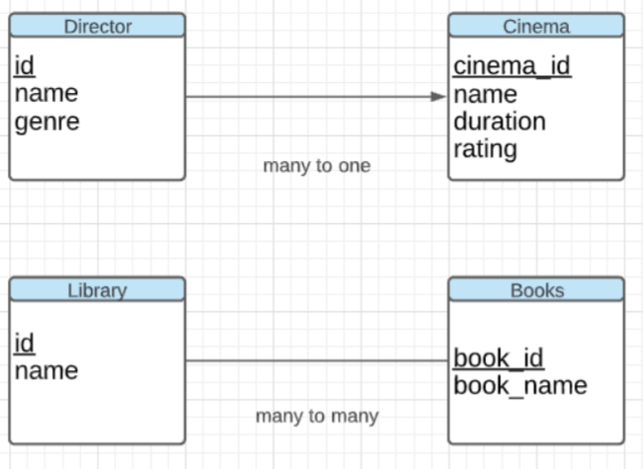

1. 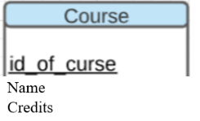 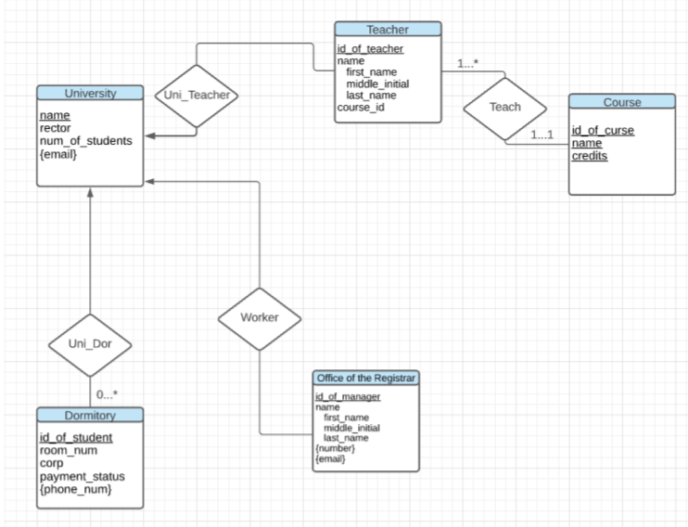
2. 